Crime Prevention within Metro Systems

Article for The European Journal on Criminal Policy and Research, vol. 4.4,
by Drs. Manuel J.J. López, Result Crime Management, december 1996

Introduction

The subject of crime and crime prevention within metro systems has gained increased attention in recent years. This may be no surprise, since criminal damages (in direct financial losses, repair costs, security measures, and loss of passenger revenue) often exceed the millions. More and more metro companies have started to look for cost-efficient solutions to counter the threats of crime and provide passengers with a higher standard of service. In their efforts to combat crime and insecurity metro companies and security experts have, however, been handicaped by the limited availability of theoretical knowledge on this subject. There have been studies on the possibilities to tackle single crime problems within the metro (Gaylord & Lester 1994, Sloan-Howitt & Kelling 1990), studies on crime control in individual metro systems (Gaylord & Galliher 1991, Webb & Laycock 1992), and studies on the effectiveness of individual measures (Clarke 1993, Eastman & Yuan 1994). What has been missing, however, is comparative research that provides insight into the factors that influence criminal opportunity within metro systems and a publication that offers a complete instruction on how to build and manage a system that limits the opportunity for crime to the extent possible. To meet this need an international comparative study was started among twelve metro systems in Asia, Europe, Latin America, and the United States which has recently resulted in the publication of a book. This article provides a summary of the book and gives an overview of the main conclusions.

History

The development of knowledge on crime prevention construction and management of metros can be seen as a process that elapsed in a non-linear fashion. Therefore, these can be divided into different distinguishable phases. In the early days of metro construction (1863 till the early 1960's), no consideration whatsoever was given towards a preventive design, planning, or management of the metro systems. Crime rates were relatively low and crime prevention knowledge was virtually non-existent. The only form of crime control at the time was repression and this was working fine both in the societies as a whole and within the first constructed metro systems. This situation changed, however, in the 1960's when the crime climate in the Western societies began to deteriorate. Crime rates boosted and conventional repressive techniques proved to be no longer adequate. The then existing metro companies tried hard to combat crime with the tactics of 'target hardening'; iron fences, steel doors, and dog patrols were utilized in the hope that they could deter crime. Although these techniques had some effects, they also had serious deteriorating repercussions on the looks and atmosphere of the metro systems, and consequently, the feelings of insecurity and well-being of the passengers and metro personnel. The mid 1970's can be seen as the dawning of a new era. By then, scientific knowledge on crime prevention techniques had developed to such a level that it was fit to be put into practical use. Little by little, metro companies started to benefit from the newly emerged knowledge and began to devote attention to a more preventive approach to crime. Target hardening techniques were abandoned more and more and the preventive focus was directed more towards the improvement of visibility, social control, and environmental friendliness. The breakthrough to this latest phase was made in 1976 when the Washington D.C. Metro opened its doors. The construction of this system revolutionized metro design as it had given top priority to crime prevention and, therefore, incorporated the latest knowledge in that field.

Although there has certainly been an international accumulation of practical and theoretical knowledge on crime prevention strategies which are successful within metro systems, this does not mean that this available knowledge has also been utilized to the full. Not every new metro system was constructed in a safer way than its predecessors. Existing systems often had to deal with the handicap of old but influential bureaucratic organisations and original system constructions in their ability to radically reorganise their crime prevention policy and actions. There have been a number of crime prevention studies on specific aspects of the metro. However, overall studies on the scope and nature of subway crime and the possibilities and effectiveness of crime prevention actions are rare. Crime prevention plans of metro companies are more often based on the intuition and personal opinions of managers than on in-depth research. The few studies that have been done are based on local information and rarely surpass the borders of the country or even the local system. And saddest of all: crime prevention knowledge is sufficiently available within the international community of metro companies, but scattered among the different systems. This is especially true for knowledge on the various crime prevention strategies. Some metro companies are real masters in the utilization of one crime prevention technique (e.g. the facilitation of policing) but have little to no knowledge of other techniques (e.g. stimulation of involvement). They think that they are doing their utmost in combatting crime within their system, but what they don't know is that their approach is one-sided and ignoring the fact that crime prevention can only be really effective when it is made up by a set of mutually reinforcing strategies.

Right now, we are at the doorstep of yet another phase in the history of metro crime control: the integration of crime prevention into the general goal for Total Quality Management and a higher level of passenger service. In this new era, crime control will no longer be seen as a goal in itself but more and more as a cost-effective means to establish a friendlier atmosphere, better company image, and higher revenue. Crime prevention measures will become less focused on crime prevention alone. They will become more integrated into the planning and design of the system, the day-to-day management routine of the organisation, and less obvious to the unweary passenger. This approach will not only prove to be friendlier; it will also be more effective in terms of crime prevention and beneficial to other company goals such as accident and fire prevention, image enhancement, cost reduction, and revenue increase.

The international comparative study

When metro systems will be able to enter the new era of crime control depends on a number of factors. First of all, the available but scattered knowledge on effective crime prevention techniques must be collected and modelled into a newly integrated approach. The latest scientific knowledge on criminal opportunity must be pitted against the practical experiences of metro companies. Information on successful strategies must be gathered in different parts of the world and a scientific model must be developed. This scientific model must give insight into the best combination of prevention strategies within metro systems and their relationship with crime and criminal opportunity. But more important, the model must be translated into concrete and practical guidelines. A set of requirements must be developed that gives detailed information on how the (abstract) scientific criteria can be translated into concrete construction and management of the metro system. These guidelines must be internationally applicable, clearly formulated, and easy to implement. They must be useful for the construction and security organisation of new metro systems as well as for the improvement, reconstruction, extension, and reorganisation of existing metro systems.

To meet all these needs, an international comparative study was started on the relationship between criminal opportunity and the construction and management of metro systems.

Objectives of the international comparative research were:
- to gain insight into the factors that influence criminal opportunity in metro systems (theoretical relevance) and
- formulation of practical guidelines for the improvement of public safety in existing and future metro systems (practical relevance).

To achieve these objectives, a research design was chosen in which lessons are gained from the experiences of existing metro systems in Asia, Europe, Latin America, and the United States. During a period of 21 months a total of twelve metro systems were visited, observed and photographed. These are the metro systems of Tokyo, Hong Kong, Singapore, Taipei, New York, Washington D.C., São Paulo, Prague, Budapest, Amsterdam, London, and Paris. Existing documentation and crime statistics were collected and analyzed. Constructional aspects of the systems were photographed and studied on location. In six of the twelve metro systems, proper authorities were contacted and interviewed on their crime prevention approaches, problems, and experiences. These are the authorities from the metro systems of Hong Kong, Singapore, Taipei, São Paulo, Amsterdam and London.

Research findings

Gaylord and Galliher (1991) distinguish three factors to explain the low crime rates in the Mass Transit Railway system of Hong Kong: the low incidence of crime in Hong Kong society, the efficient working method of the MTR police, and the cunning planning and design of the MTR trains and stations. This model is an adequate explanation for the situation in Hong Kong but needs further adjustment to gain international validity.

The incidence of crime and feelings of insecurity within metro systems can best be explained by the following model.

Model. Criminal incidence within metro systems

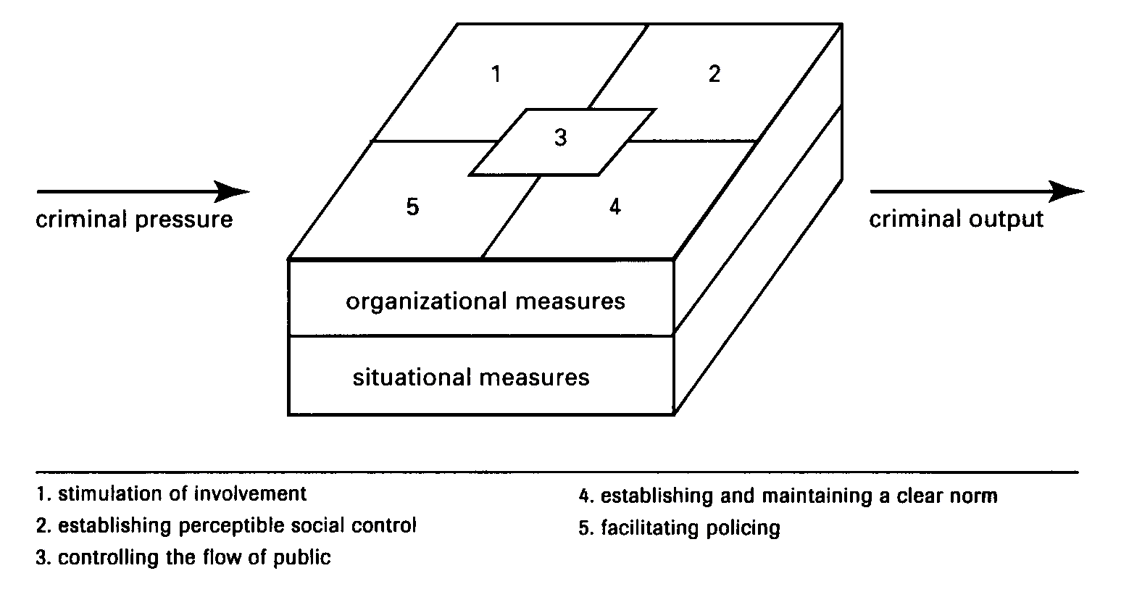
The occurrence of both objective ('common' as well as terrorist) crimes and feelings of insecurity within metro systems is conditioned by the amount and nature of crime in the direct environment of the metro system and the criminal opportunities limited or created by the total set of situational and organisational measures within the metro system. The amount and nature of crime in the neighbourhoods where the metro stations are situated are a result of historical, cultural, social, and political factors falling outside the sphere of influence of the metro operators. Because of this, they must be regarded as the given fact of external criminal pressure. The criminal pressure on a metro system is filtered by the total set of crime prevention measures consciously or unconsciously implemented within the metro system. This total set of measures creates or limits the opportunity for crimes to take place within the premises of the metro system and influences the passengers' feelings of safety. In contrast to external criminal pressure, criminal opportunity within the system cán be influenced by the managers and constructors of the metro system. Successful sets of crime prevention measures are characterized by the fact that they limit criminal opportunity to a degree that the scope of crime within the metro system is considerably lower than the crime level in its direct environment. Inadequate implementation of the measures results, on the other hand, in a rather limited prevention effect or even in the creation of criminal opportunity.

The international comparative study has recovered five different crime prevention strategies which can be applied to limit the opportunity of crime and feelings of insecurity within the premises of metro systems. These crime prevention strategies are: the stimulation of involvement, establishing perceptible social control, facilitating policing, establishing and maintaining a clear norm, and controlling the flow of public. All of these strategies are known to the international theories of crime prevention and have both a situational as well as an organisational component. In spite of the availability of theoretical knowledge on these strategies they are, however, applied with different degrees of profoundness by the various operators of the studied metro systems. Practical knowledge on implementation of these strategies within metro systems seems to be scattered among the different countries and their respective metro corporations. Every metro corporation holds some pieces of knowledge, but only a few have a grip on the whole set of preventive requirements. In virtually all systems, some strategies are implemented to a high level of profoundness, while other strategies are simply neglected. The causes of these inconsistencies can be found in the history of the respective metro corporations and the culture of the country and city in which they are situated. Hong Kong, for example, has much more experience with and less restraint toward the deployment of police officers within the metro system than, for example, Amsterdam. This results in more attention paid to the facilitation of policing through design and management requirements in the Mass Transit Railway system of Hong Kong than in the subway of Amsterdam. In most of the metro systems, much can be done to improve the full application of the total set of crime prevention principles.

The theoretical backgrounds of the five crime prevention strategies and their practicle consequences for the construction and management of metro systems are extensively treated in the book and outside the scope of this article. However, it is important to state that the application of individual strategies will have some effect, but that their real strength will only become visible when they are realised together in a balanced mix of mutually attuned measures. The individual strategies are highly interconnected and mutually reinforcing. Application of the whole range of the five crime prevention strategies will have a big synergistic effect in which the combined crime prevention effect is many times bigger than the sum of its parts.

The publication 'Crime Prevention Guidelines for the Construction & Management of Metro Systems' can be ordered through Result Crime Management, P.O. Box 82027, 2508 EA Den Haag, the Netherlands; m.lopez@RCM-advies.nl.

